# V2X HUB Length of Queue Logic

This document outlines the estimation of traffic queue length for V2X Hub. The queue is defined as the distance from the furthest stopped vehicle to the stop bar at each lane and each direction of the intersection. The queue length of traffic upstream of an intersection is estimated in meters or feet for each lane of each intersection direction. In traffic engineering, it is important for operations (and to avoid spillback and turn bay blockage) to measure not the number of stopped vehicles, but the distance from the last stopped vehicle to the stop bar.

## Requirements and Assumptions

* Connected vehicles are equipped with OBUs.
* Connected vehicles should be able to frequently send BSMs to V2X Hub through an RSU when entered to a certain vicinity of the RSU.
* V2X Hub should be able to frequently receive SPaT messages from the signal controller.

## Inputs to the Queue Length Estimation Algorithm

* BSM
  + Vehicle location
  + Vehicle speed
  + Vehicle acceleration
* MAP
  + Roadway geometry
* SPaT
  + Real-time signal statues (i.e., red or green)
* Parameters
  + RSU detection space range
  + Stopping speed range (~1 m/s)
  + Default backward shock-wave speed 1 (depends on traffic demand, see Figure 2)
  + Default backward shock-wave speed 2 (~ 10.5 m/s, see Figure 2)

## Steps to the Queue Length Estimation

As the inputs are continuously fed into V2X-Hub, the queue estimation algorithm below is repeated at every predetermined time interval. Also, these steps are applied to each lane of each direction separately. Let $t$ define the current time.

1. Update the list of connected vehicles located in the RSU range.
2. Update vehicle positions, speeds, and accelerations in the list. BSM messages include vehicle positions formatted as GPS coordinates (i.e., latitudes and longitudes). These coordinates should be converted into a longitudinal coordinate system that decreases as the vehicle approach the intersection and the origin of the coordinate system is set to the stop bar location. Each direction can be assigned to one longitudinal coordinate system. Figure 1 illustrates the longitudinal coordinate system along a direction of a roadway.

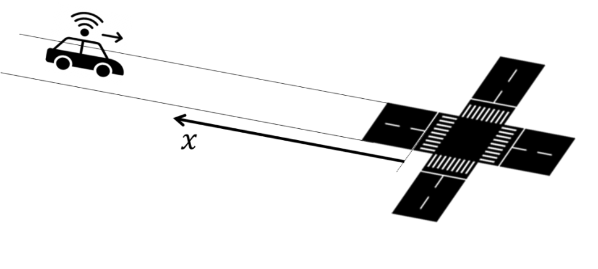

Figure 1 Longitudinal coordinate system (source: FHWA).

1. Sort vehicles according to their distance from the stop bar or their values in the longitudinal coordinate system in ascending order. For system efficiency, V2X-Hub may save the order obtained from the previous algorithm iterations, and update that as a vehicle enters the range, change lane, or departs from the intersection.
2. Update vehicle states and the corresponding state change times. For each vehicle in the list, we define two states: moving and stopping. A vehicle is set to the stopping state when its speed drops to a value less than the stopping speed range parameter, and moving state otherwise. Depending on the quality of acceleration profiles provided by the BSM messages, we may be able to use both speed and acceleration characteristics to classify vehicle states. V2X-Hub records the vehicle states and the corresponding state change time, defined as stopping and accelerating times and adds them to the list. The accelerating times are only defined when the signal is green and thus the vehicles start accelerating to traverse through the intersection.
3. Update the shockwave speeds. We define two backward shockwaves. The first one separates the change of vehicle states from the moving to stopping states as vehicles approach the intersection. The second one separates the state changes from stopping to moving as vehicles start accelerating when the signal turns green. Figure 2 illustrates the two backward shockwaves in a space-time diagram. This figure shows vehicle trajectories for a stream of vehicles approaching a signalized intersection. The traffic signal status is shown as red, green and yellow bars at the intersection (shown at top of the figure). A portion of vehicles in this figure are connected (OBU-equipped) vehicles, which their trajectories are shown as solid red curves, and the remaining vehicles with dashed-blue trajectories are not connected. The non-connected vehicle trajectories are invisible to the RSU. However, the location of connected vehicles can be broadcasted to the RSU at any time once they are in the RSU detection range. The 4-point orange and 5-point green stars in Figure 2 indicate the stopping and accelerating space-time points, respectively. These points actually separate the vehicle states in the space-time diagram. Connecting the stopping space-time points together yields shockwave 1, as shown as dashed red line. Similarly, we can obtain shockwave 2 by connecting the accelerating space-time points together, shown as dashed green line.

The speeds of these shockwaves, which are the absolute values of the shockwave slopes in the space-time diagram can be determined by fitting a linear regression model to the corresponding points in the space-time diagram, calculated as

$$w_{s}=\frac{I_{s}\left(\sum_{i}{t_{si}p_{si}}\right)-\left(\sum_{i}{t_{si}}\right)\left(\sum_{i}{p_{si}}\right)}{I_{s}\left(\sum_{i}{t_{si}^{2}}\right)-{\left(\sum_{i}{t_{si}}\right)}^{2}},s=1,2,$$

where $w_{s}$ is the shockwave speed $s$, $I_{s}$ is the number of stopping/accelerating points used for estimating the speed of shockwave speed $s$, and $t_{si}$ and $p_{si}$ are the time and location of point $i$ along shockwave speed $s$, $∀i=1,2,…,I_{s},s=1,2$, respectively. Note that in order to estimate the shockwave speeds with the linear regression formula, at least two stopping/accelerating points are required for each of the shockwaves. In case that only one stopping/accelerating point is available for each of the shockwaves, the corresponding shockwave speed(s) is(are) set to the default value(s) defined in the set of parameters. For shockwave 1, different default values can be estimated using offline historical traffic data for different times of a day during weekday, weekend, and special event periods or can be estimated in real-time using the estimated traffic flow. However, shockwave 2 default value can be set to a single static value that depends on the intersection saturation flow rate and jam density, which can be also calibrated using historical traffic data.

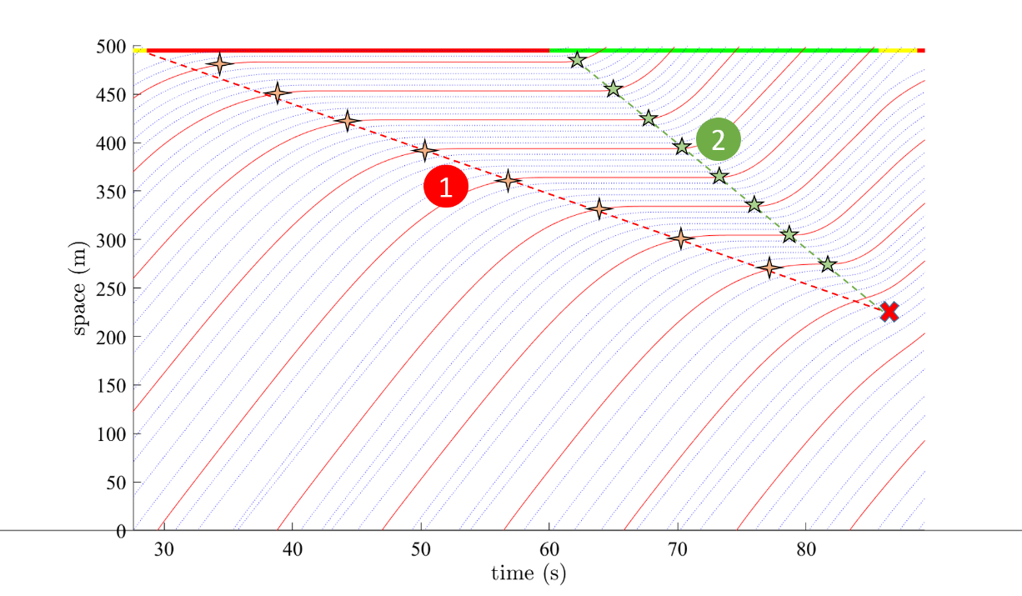

Figure 2 An illustration to backward shockwaves (source: FHWA).

1. If the signal status is green, then update the queue length upper bound. It can be shown that the queue cannot spill back farer than the intersection between the two shockwaves illustrated as red multiply symbol in Figure 2. This upper bound can be updated once the signal turns into green, and shockwave speeds 1 and 2 are estimated. Let $\overline{Q}$ denote the queue length upper bound that is calculated as follows. Figure 3 illustrates $\overline{Q}$ estimation for two traffic scenarios: relatively high and low demand cases, as shown in Figure 3(a) and Figure 3(b).

$$α_{s}=\frac{\left(\sum_{i}{p_{si}}\right)\left(\sum_{i}{t_{si}^{2}}\right)-\left(\sum_{i}{t_{si}}\right)\left(\sum_{i}{t_{si}p_{si}}\right)}{I_{s}\left(\sum_{i}{t_{si}^{2}}\right)-{\left(\sum_{i}{t_{si}}\right)}^{2}},s=1,2,$$

$$\overline{Q}=\frac{α_{1}w_{2}+w_{1}w_{2}R-α_{2}w_{1}}{w_{2}-w_{1}},$$

where $α_{s}$ is the shockwave function intercept for $s=1,2$, and $R$ is the signal red time interval.

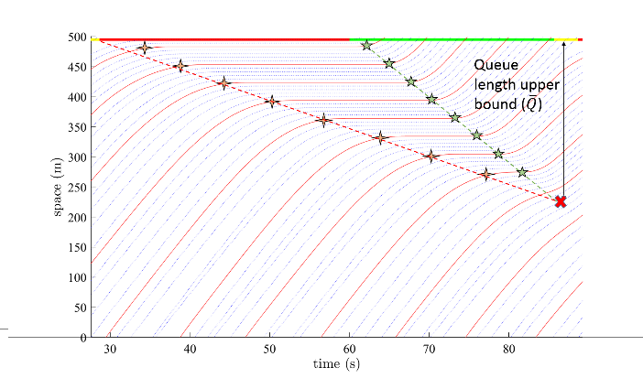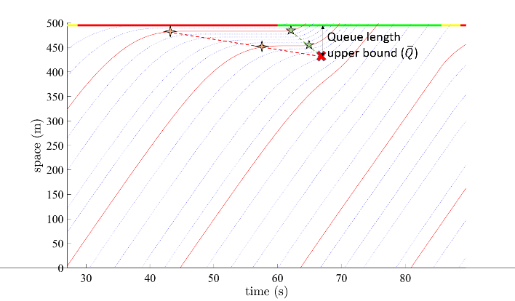

(a) (b)

Figure 3 An illustration to queue length upper bounds in a) high demand and b) low demand scenarios (source: FHWA).

1. Estimate the queue length. The corresponding distance to the stop bar of the last stopped vehicle provides a lower bound to the overall queue length. However, it is likely that there are other queued vehicles behind the last connected vehicle. Therefore, we need to extend the last known stopping location using the speed of backward shockwave 1 to obtain the queue length. The extension distance is determined by multiplying the shockwave speed 1 by the time difference between current time *t* and the last stopping time. If the signal is green, and thus a queue upper bound is available, then the estimated queue length should be compared with the upper bound and modified accordingly, otherwise we set $\overline{Q}$ to infinity. Let $Q$ denote the queue length*,* which is calculated as follows. Figure 4 illustrates the queue length estimation.

$$Q=min\left(\overline{Q},p_{1I_{1}}+w_{1}\left(t-t_{1I_{1}}\right)\right)$$

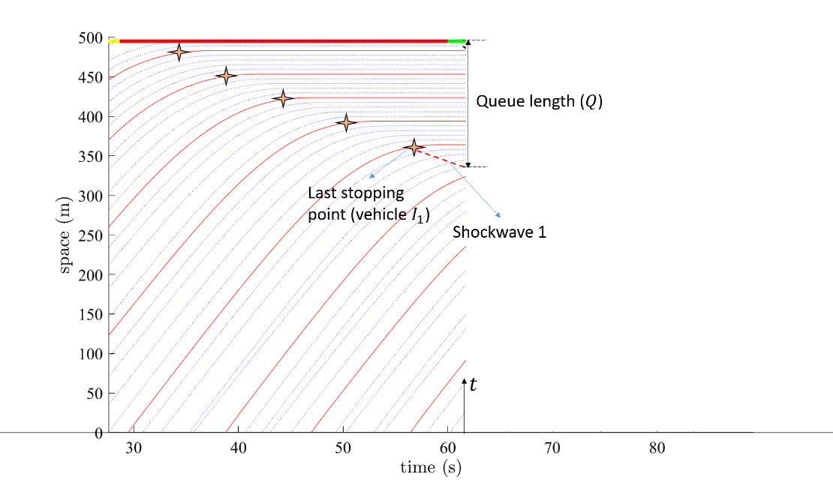

Figure 4 An illustration to queue length estimation (source: FHWA).

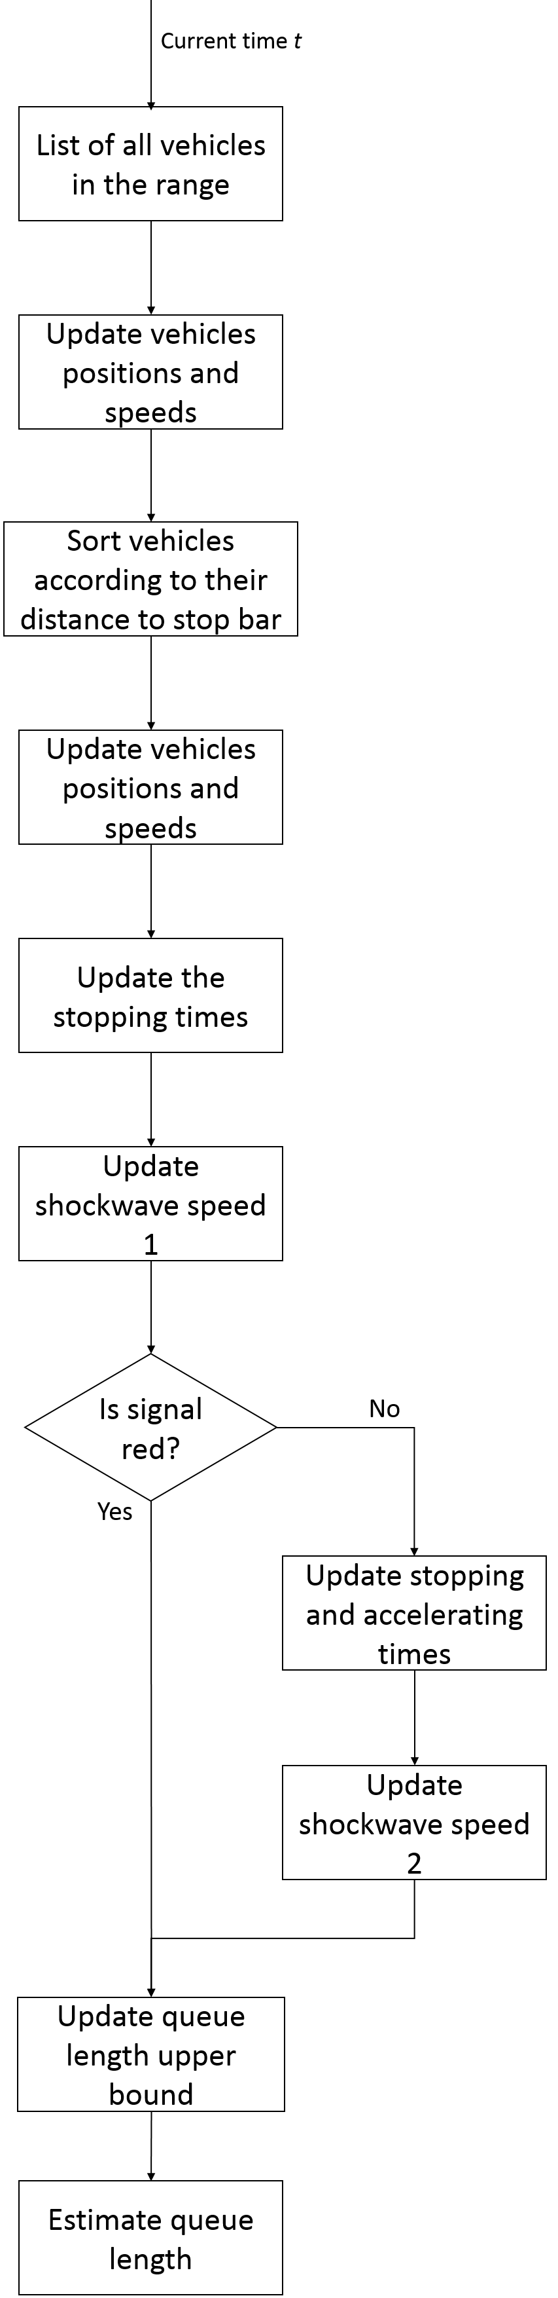

Figure 5 Queue length estimation algorithm flowchart (source: FHWA).